

Spire Change Management Process

As of September 11th, 2017

Contents

Spire Change Management Policies: 3

For ISO Documentation SpiremtSCM/SpireISO Private 3

Spire Agile Development Process 5

**Spire will be following this Agile Process to be efficient as possible:** 5

Spire GitHub Artifact Naming Convention 6

Links Directly to Spire Github 6

• SpireISO Private 6

• SpireMT_Pilot Private 6

# 

# Spire Change Management Policies:

This policy must be adhered to for any and all documents will be reviewed before release, I will be putting together Change Control.  This will encompass the policies and procedures for which change can happen is Github.

**All changes** must be documented with Release Notes to be put into Github. Link to  [Adding Files to SpireSCM Repositories.docx](https://github.com/SpiremtSCM/GVFS/blob/master/Adding%20Files%20to%20SpireSCM%20Repositories.docx" \o "Adding Files to SpireSCM Repositories.docx)

Link to Spire Mandatory SCM  <https://github.com/SpiremtSCM/GVFS/blob/master/Spire%20Mandatory%20Source%20Code%20_Documentation%20Control%20System.docx>

**Spire Change Control Process**

For Spire Artifacts:

All artifacts to be stored in Spire Github REPOSITORIES listed below for Spire Change Management located at <https://github.com/SpiremtSCM> see Repositories Section Below

Bottom of Form

# For ISO Documentation [SpiremtSCM](https://github.com/SpiremtSCM)/[SpireISO](https://github.com/SpiremtSCM/SpireISO) Private

Go to you download folder
Enter Changes to you r downloaded version  

 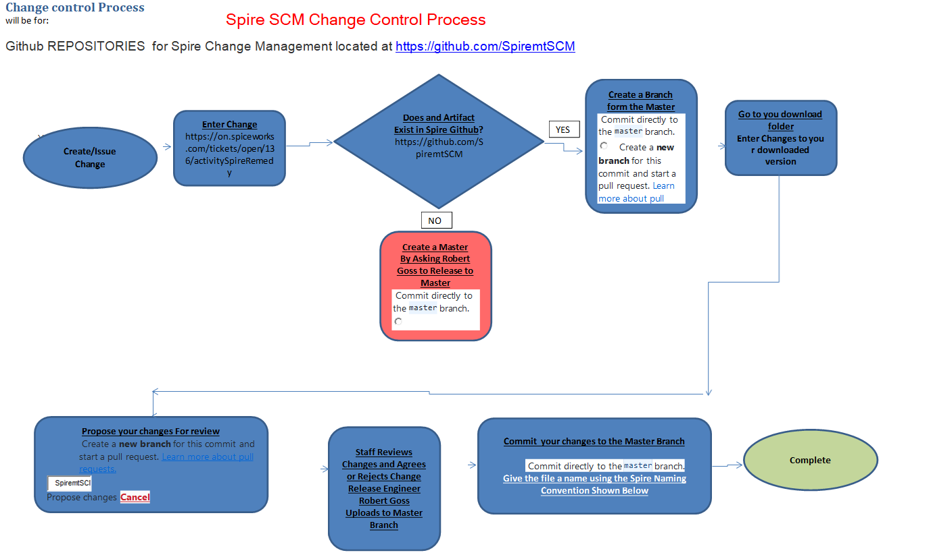

## Spire Agile Development Process

**Spire will be following this Agile Process to be efficient as possible:**

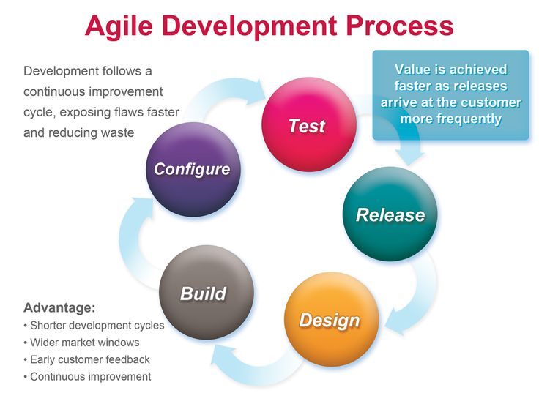

## Spire GitHub Artifact Naming Convention

Must be used

**Naming Convention Example to go be uploaded into Master branch**

**User’s Manual** - EF40UsersManualCurrent Data sheet

**Product Datasheets** - EF40DataSheetCurrent Quick Start

**Quick Start Guides** - EF40QuickStartCurrent Firmware –

**Product Firmware** - EF40FirmwareCurrent Source Code –

**Product Source Code** - EF40SourceCodecurrent Drawings - EF40

**Product Drawing File** - DrawingName_1_Current BILL OF Materials - EF40BOMCurrent

Click link and Start Adding Source or documentation, these Spire Repositories will be point of record for all future information and will be the MASTER point of orgigen for spire source code and Documentation

## Links Directly to Spire Github

Private Access by Select Staff Only

### [SpireISO](https://github.com/SpiremtSCM/SpireISO) Private

SpireISO

### [SpireMT_Pilot](https://github.com/SpiremtSCM/SpireMT_Pilot) Private

Pilot

* [**Spire-Product-Datasheets**](https://github.com/SpiremtSCM/Spire-Product-Datasheets)

[Spire-Product-Datasheets](https://github.com/SpiremtSCM/Spire-Product-Datasheets)

* [**Spire-EF10-TP10**](https://github.com/SpiremtSCM/Spire-EF10-TP10)

Spire EF10-TP10

* [**Spire-EF40**](https://github.com/SpiremtSCM/Spire-EF40)

Spire EF40

* [**Spire-EF12**](https://github.com/SpiremtSCM/Spire-EF12)

Spire EF12

* [**Spire-280T-S**](https://github.com/SpiremtSCM/Spire-280T-S)

Spire 280T-S

* [**Spire-280W-D--CI**](https://github.com/SpiremtSCM/Spire-280W-D--CI)

Spire 280W-D--CI

* [**Spire-280W-R**](https://github.com/SpiremtSCM/Spire-280W-R)

Spire 280W-R

* [**Spire-MAG888--Flowmeter**](https://github.com/SpiremtSCM/Spire-MAG888--Flowmeter)

Spire MAG888--Flowmeter

* [**Spire-MAG-888-DC**](https://github.com/SpiremtSCM/Spire-MAG-888-DC)

Spire MAG-888-DC

* [**Spire-T-MAG-BTU**](https://github.com/SpiremtSCM/Spire-T-MAG-BTU)

Spire T-MAG-BTU

* [**Spire-280T**](https://github.com/SpiremtSCM/Spire-280T)

Spire 280T

* [**Spire-280WR**](https://github.com/SpiremtSCM/Spire-280WR)

Spire 280WR

* [**Spire-280WCI**](https://github.com/SpiremtSCM/Spire-280WCI)

Spire 280WCI

Spire Product-Datasheets

* [**GVFS**](https://github.com/SpiremtSCM/Spire-280WCI)

Spire Virtual File System